SWE20001 – Development Project 1: Tools and Practices

Team Report For Week (3)

Duy Phuong Nguyen (101204984)

Lab: Friday 2:30pm

Tutor: Huai Liu

Team number: 3

Henry Tran 102075482

Edward Knight 102700043

Duy Phuong Nguyen 101204984

Christian Ilott 102169762

**Team report week 3: Submission details and assessment criteria**

The following photos (**with annotations for explaining what we did**) capture the process our team used to perform the tasks required in Activity 3.1:

1. Firstly, Henry created a voice chat channel on Discord. We think Discord is better than Slack because we can’t do voice chat in Slack.

I (Duy Phuong Nguyen) was voted to be the team leader of group 3 this week

However, one of our team’s members didn’t show up so we decide to wait him for a bit.

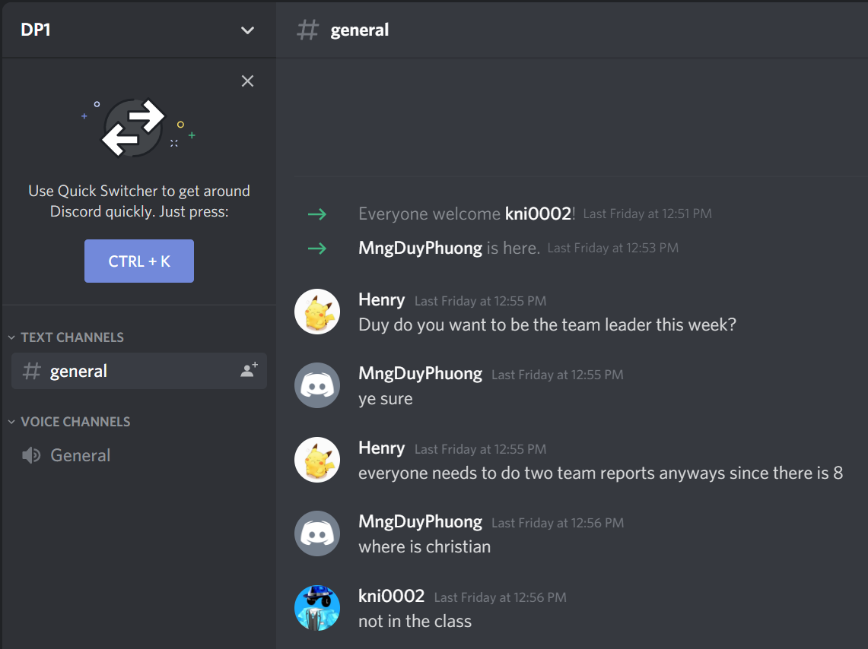

1. As the team’s leader, I create a project on GitHub and invited all our group members: Henry and Edward.

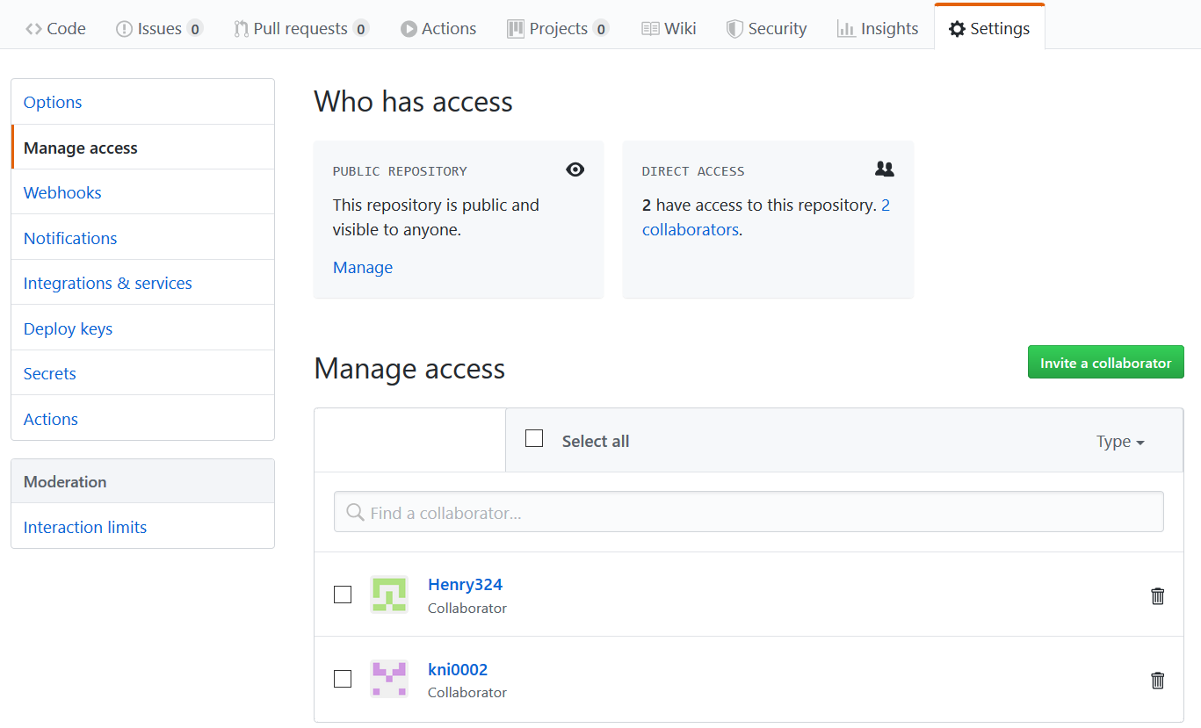

1. Then I create a homepage and required pages (with “Add a custom sidebar” function) for this wiki so our group can start working. I’m also Numbering all the pages.

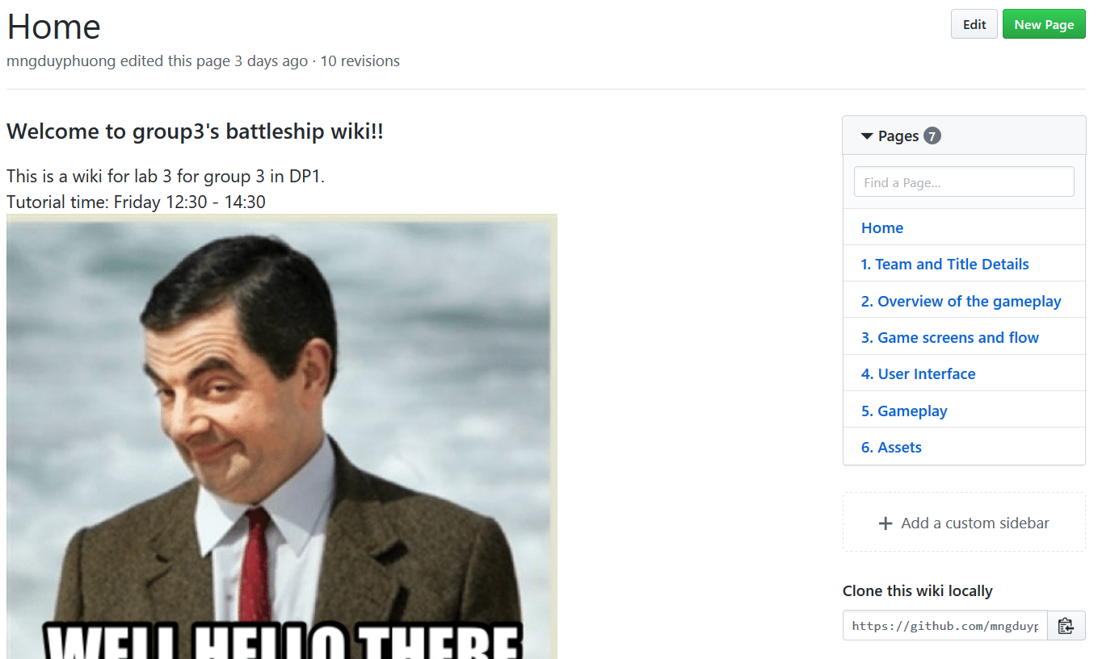

1. After waiting Iloot for 30 minutes, we decided the task of this week is divided between 3 members: Duy Phuong, Henry, Edward.

* Duy Phuong: team leader, part 1 and part 4.
* Henry: part 2, part 5 and part 6.
* Edward: he has the hardest part which is part 5 “Game screens and flow”. This one requires some designing skills.

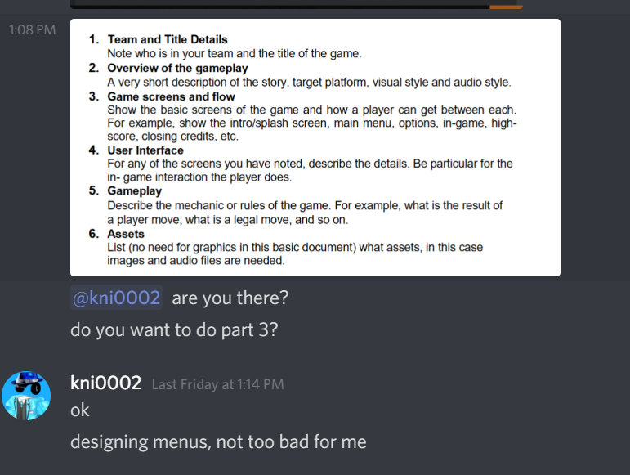

1. We then using voice chat to discussed about game details, gameplay, features, e.t.c . Every team member contributes their ideas, images.

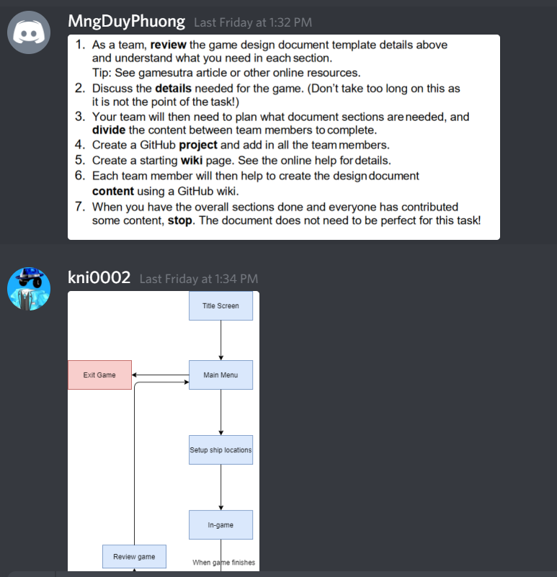

1. We completed our parts and then help each other to check and provide feedbacks.

* Duy Phuong: Team and Title Details, User Interface. After Edward provided his ideas about the game screens and flow, I finish my part 4 based on his idea.

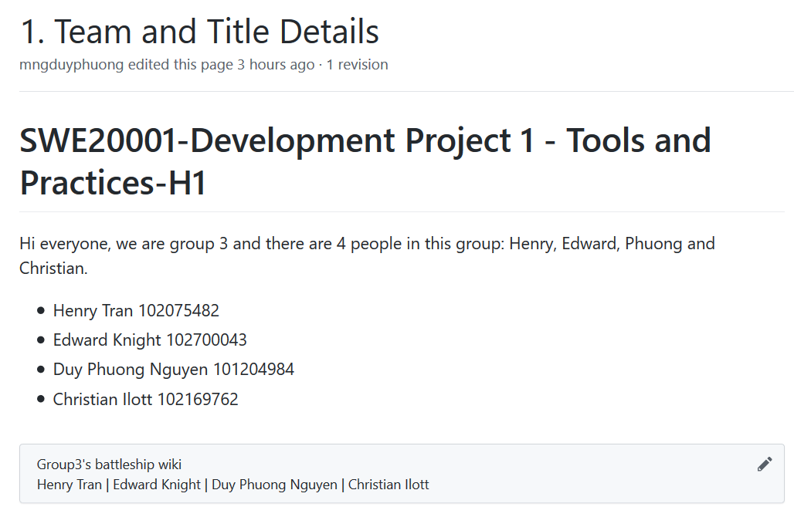

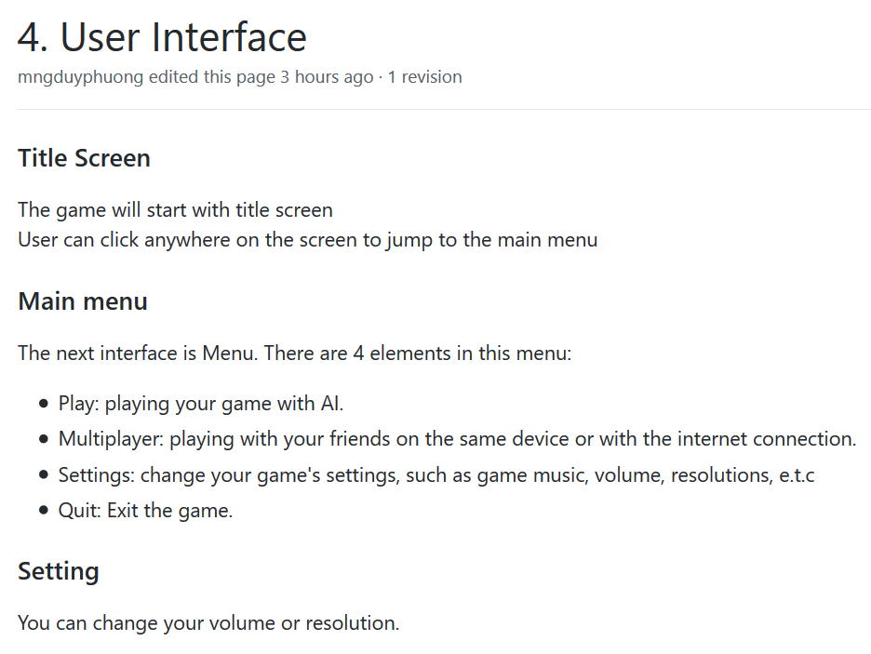

* Edward: Game screens and flow. He used a flowchart to present his idea of battleship game. Menu and in-game images are also added to this wiki page.

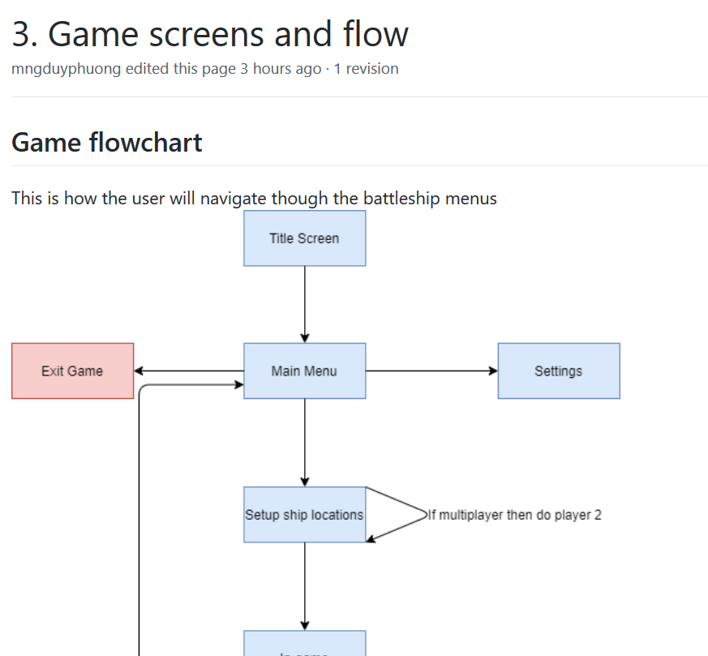

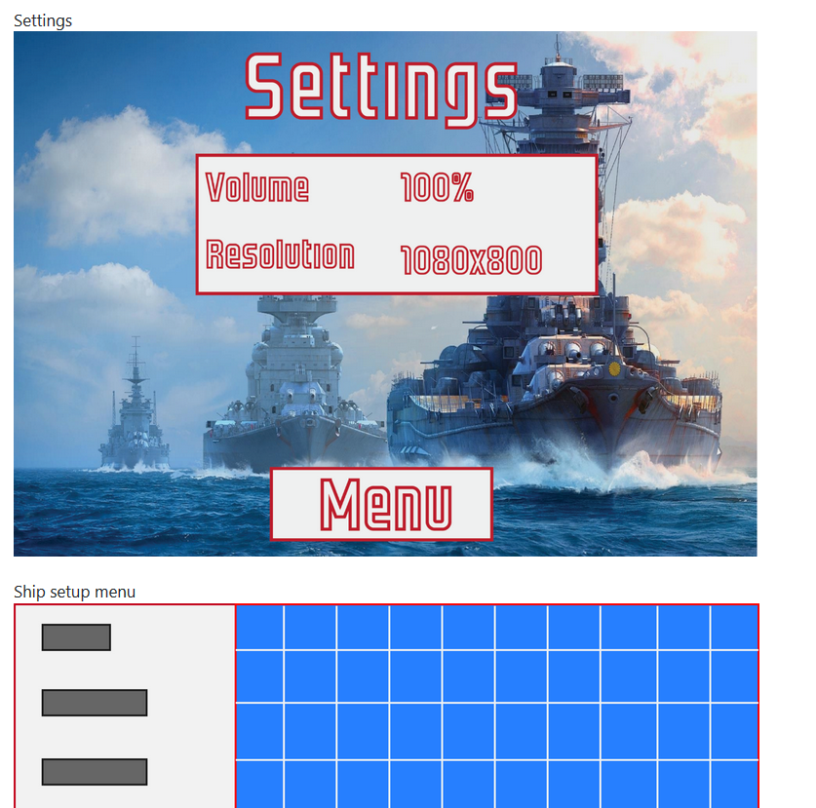

* Henry: Overview of gameplay, gameplay and assets. A short and a full description about gameplay are added to “Overview of gameplay” and “Gameplay” respectively. In Assets page, there are two main headings: audio and images.

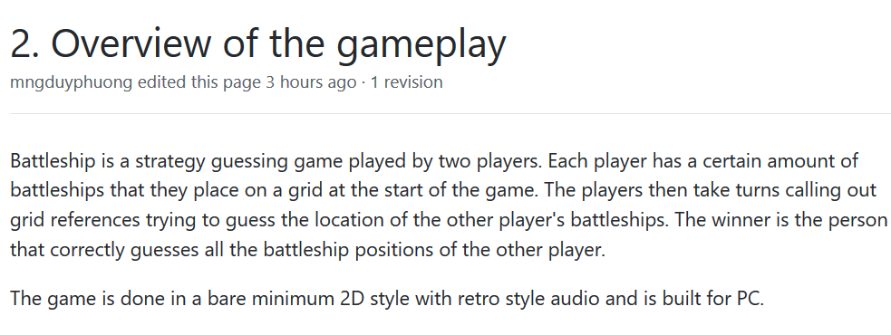

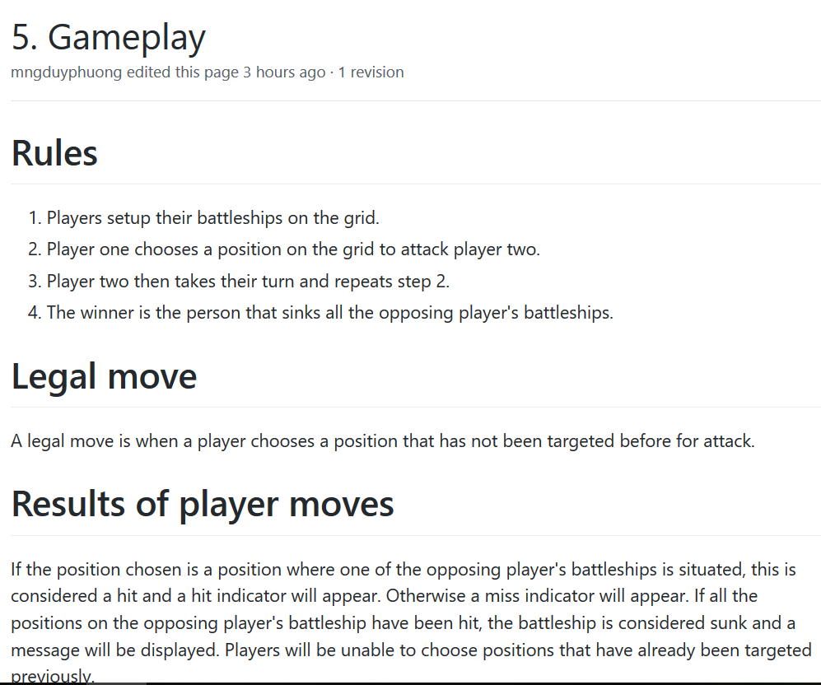

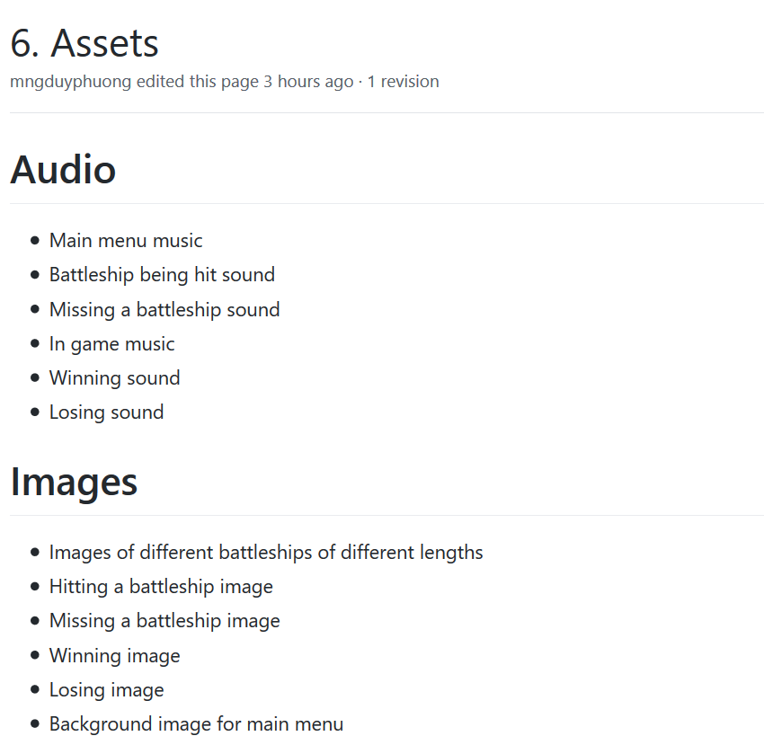

GitHub URL: <https://github.com/mngduyphuong/battleship-lab03/wiki>